**Unit 5 – Worksheet 3**

**Elevator Ride – Data Analysis**

After watching the video of the elevator ride, analyze the data illustrated by the graphs. The person was ***at rest*** on the 15th floor at the beginning of the elevator ride. The person was standing on a force plate (scale) which measured the amount of force exerted on the plate by the person, and therefore also the amount of upward force on the person by the plate. In the exercises below, consider the motion and forces on the person for each labeled section of the graph.

Draw a *qualitative* force diagram for a person on an elevator:

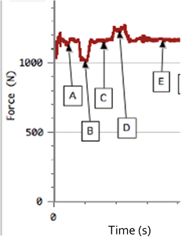

|  |  |  |
| --- | --- | --- |
| **@ const vel** | **Accelerating up** | **Accelerating down** |
|  |  |  |

1. Based on the graph above, what is the approximate *weight* of the person riding the elevator? How do you know… (Assume that section “A” is where the person steps onto the scale on an elevator at rest)
2. Based on your answer to part a., what is the mass of the person? (Show your work)
3. What conclusion can you draw about the motion of the elevator during section ‘C’ and ‘E’ of the graph?
4. Based on the graph and information above, give a *possible* description of the motion of the elevator.

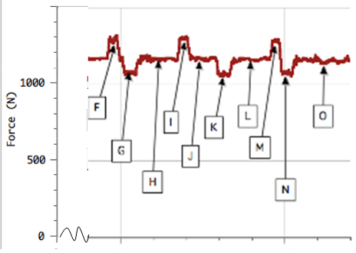The graph to the right is from the same elevator ride – assume that the elevator is at rest at the beginning of the motion shown on the graph above.

1. What do you believe is happening at section ‘H’? Explain your reasoning.

1. During which interval do you suppose was the greatest distance travelled by the elevator?

1. Draw a possible motion map for the motion from point H to point L.